# Target Metrics

Overall - Accuracy: 0.8300, Precision: 0.8399, Recall: 0.8300, F1: 0.8300

Class-specific metrics:

Carbon neutral(ity) - Precision: 0.8095, Recall: 0.6800, F1: 0.7391

Emissions reduction target - Precision: 0.8750, Recall: 0.8400, F1: 0.8571

Net zero - Precision: 0.7188, Recall: 0.9200, F1: 0.8070

No target - Precision: 0.9565, Recall: 0.8800, F1: 0.9167

# Year Metrics

Overall - Accuracy: 0.8600, Precision: 0.8654, Recall: 0.8600, F1: 0.8602

Class-specific metrics:

2020 - Precision: 0.0000, Recall: 0.0000, F1: 0.0000

2022 - Precision: 0.0000, Recall: 0.0000, F1: 0.0000

2025 - Precision: 0.6000, Recall: 0.6000, F1: 0.6000

2030 - Precision: 0.8214, Recall: 0.9200, F1: 0.8679

2031 - Precision: 0.0000, Recall: 0.0000, F1: 0.0000

2031-32 - Precision: 0.0000, Recall: 0.0000, F1: 0.0000

2032 - Precision: 0.0000, Recall: 0.0000, F1: 0.0000

2033 - Precision: 0.0000, Recall: 0.0000, F1: 0.0000

2035 - Precision: 0.8333, Recall: 1.0000, F1: 0.9091

2040 - Precision: 1.0000, Recall: 0.8000, F1: 0.8889

2050 - Precision: 0.9200, Recall: 0.8519, F1: 0.8846

No target - Precision: 0.9600, Recall: 0.9600, F1: 0.9600

# Other Metrics

Quote Accuracy: 0.7100

Overall Accuracy: 0.7800

Valid XML Percentage: 1.0000

# Confusion Matrices

Target Confusion Matrix:

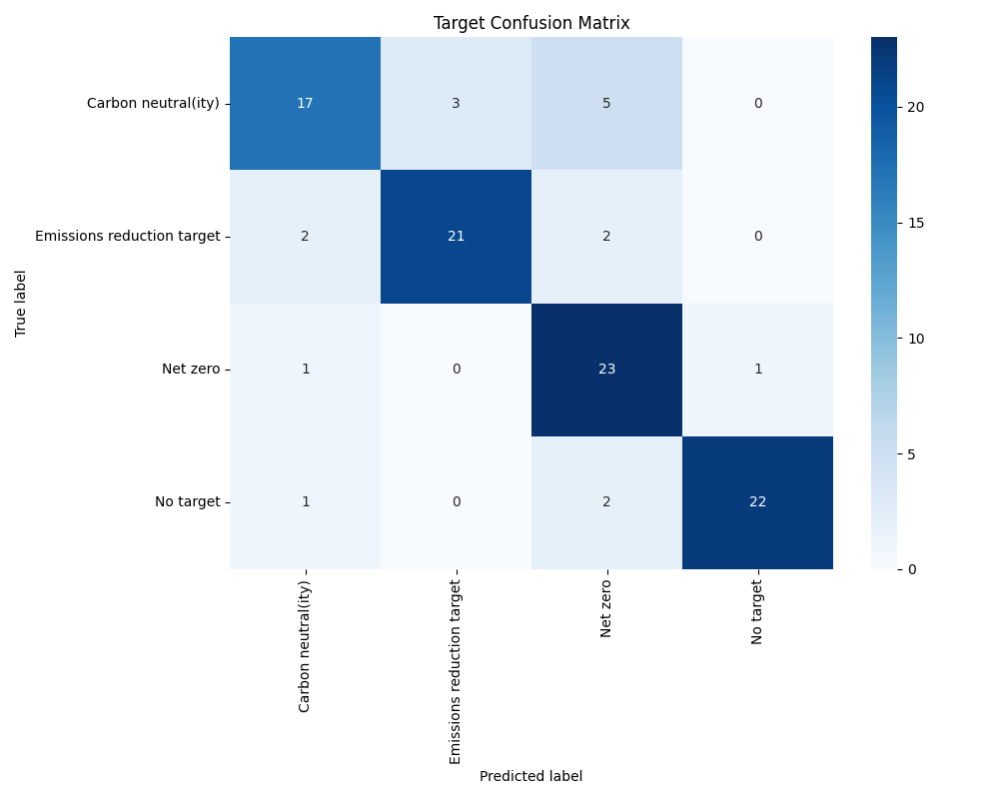

Year Confusion Matrix:

